Exception 1 : How to remove openqa.selenium.WebDriverException: Connection refused: connect while running the test case

Resolution : Some times, connection was refused by server (Appium) while running a test script.

Solution: check the IP address which is being used in the script in eclipse with the appium server IP address at which the server is listening the client request.

After both the IP addresses at client and server match, then this exception will be removed.

Here’s the example:

IP address at client side is provided as <http://0.0.0.0:4723/> but at the server end it is being provided as 127.0.0.1. So that’s why client refused exception occurred.

Client side:

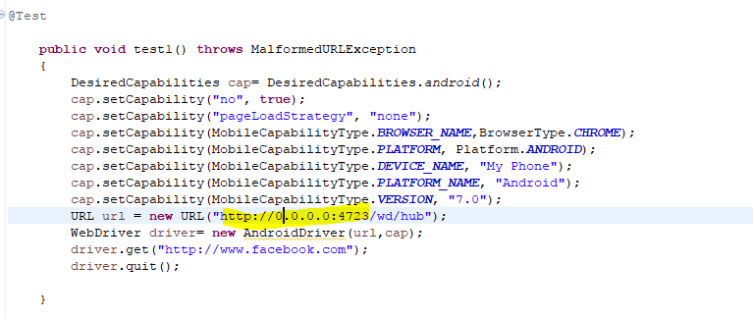

Server side:

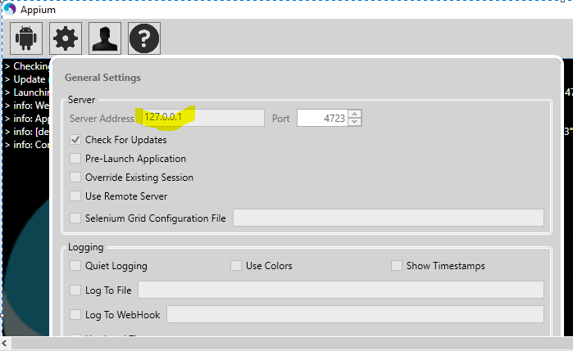

Exception 2: org.openqa.selenium.WebDriverException: org.apache.http.conn.HttpHostConnectException: Connect to 127.0.0.0:4723 [/127.0.0.0] failed: Connection timed out: connect

Or there is some exception related with unlocking then upgrade the appium to latest version i.e 1.5.x